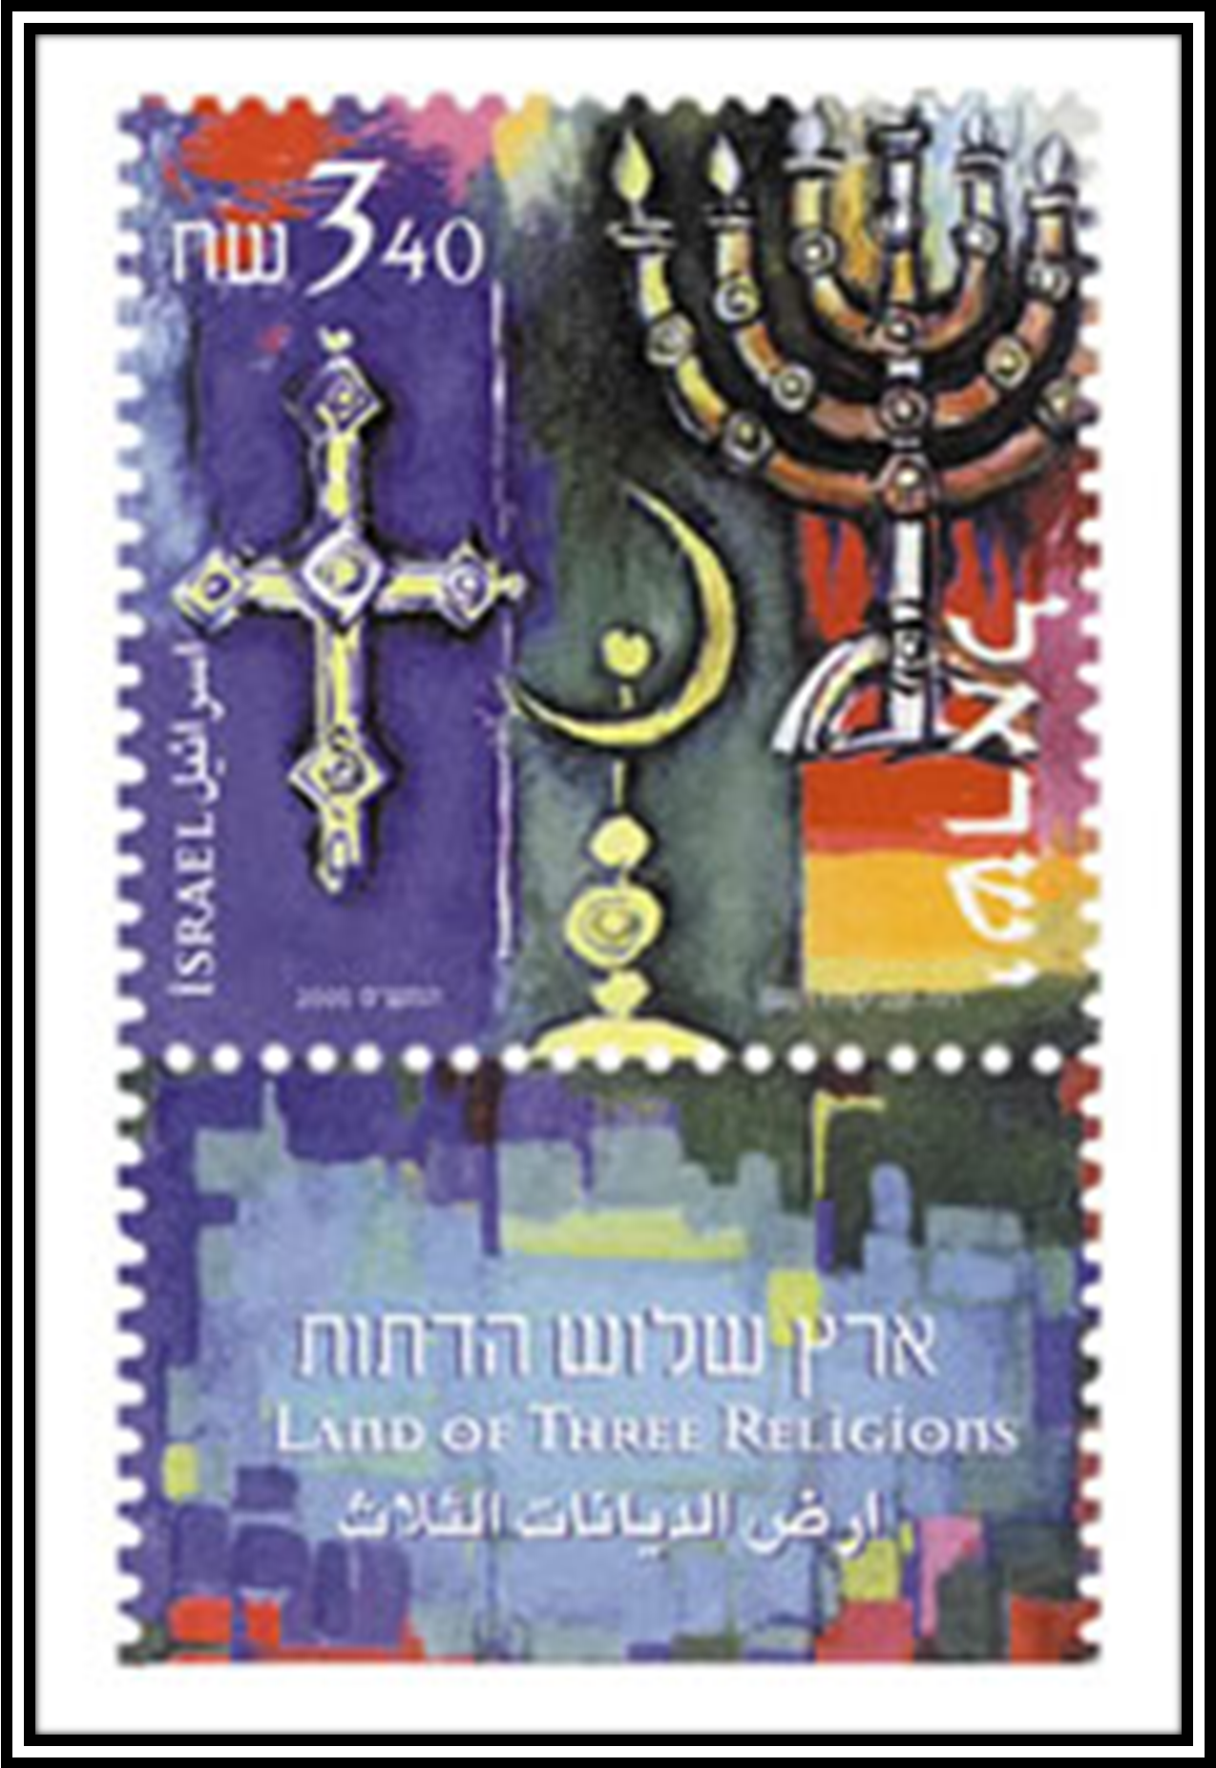
Roughly 12 percent of Israeli Jews defined as haredim (ultra-orthodox religious); an additional nine percent are “religious”; 35 percent consider themselves “traditionalists” and 43 percent are secular. 53 percent believe In God. However, 78 percent of All Israelis participate in a Passover Seder. Israelis tend to define their religious affiliation by degree of their religious practice.
76.1 percent of Israelis are Jewish
16.2 percent are Muslim
2.1 percent are Christian
1.6 percent are Druze
3.9 percent are unclassified
Religion


